**LAB # 05**

**Task # 1: Implement a full functional calculator using appropriate layout and event handling technique.**

**Solution:**

**Design:**

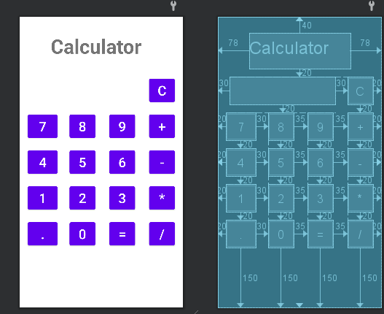

**Activity Code:**

public class MainActivity extends AppCompatActivity {

// Engine

private Button btn0,btn1,btn2,btn3,btn4,btn5,btn6,btn7,btn8,btn9,btnC,btnE,btnD;

private Button btnPlus,btnSub,btnMul,btnDiv;

private TextView txtView;

@Override

protected void onCreate(Bundle savedInstanceState) {

super.onCreate(savedInstanceState);

setContentView(R.layout.activity_main);

TextView textView = findViewById(R.id.textView2);

GradientDrawable border = new GradientDrawable();

border.setStroke(5, Color.BLACK);

border.setShape(GradientDrawable.RECTANGLE);

textView.setBackground(border);

txtView=findViewById(R.id.textView2);

btn0=findViewById(R.id.button0);

btn1=findViewById(R.id.button1);

btn2=findViewById(R.id.button2);

btn3=findViewById(R.id.button3);

btn4=findViewById(R.id.button4);

btn5=findViewById(R.id.button5);

btn6=findViewById(R.id.button6);

btn7=findViewById(R.id.button7);

btn8=findViewById(R.id.button8);

btn9=findViewById(R.id.button9);

btnC=findViewById(R.id.button_C);

btnD=findViewById(R.id.buttonDot);

btnE=findViewById(R.id.buttonEqual);

btnPlus=findViewById(R.id.buttonPlus);

btnSub=findViewById(R.id.buttonMinus);

btnMul=findViewById(R.id.buttonMul);

btnDiv=findViewById(R.id.buttonDiv);

textView.setText("0");

btn0.setOnClickListener(new View.OnClickListener() {

@Override

public void onClick(View view) {

if(textView.getText().toString()=="0"){

textView.setText("");

}

textView.setText(textView.getText().toString()+"0");

}

});

btn1.setOnClickListener(new View.OnClickListener() {

@Override

public void onClick(View view) {

if(textView.getText().toString()=="0"){

textView.setText("");

}

textView.setText(textView.getText().toString()+"1");

}

});

btn2.setOnClickListener(new View.OnClickListener() {

@Override

public void onClick(View view) {

if(textView.getText().toString()=="0"){

textView.setText("");

}

textView.setText(textView.getText().toString()+"2");

}

});

btn3.setOnClickListener(new View.OnClickListener() {

@Override

public void onClick(View view) {

if(textView.getText().toString()=="0"){

textView.setText("");

}

textView.setText(textView.getText().toString()+"3");

}

});

btn4.setOnClickListener(new View.OnClickListener() {

@Override

public void onClick(View view) {

if(textView.getText().toString()=="0"){

textView.setText("");

}

textView.setText(textView.getText().toString()+"4");

}

});

btn5.setOnClickListener(new View.OnClickListener() {

@Override

public void onClick(View view) {

if(textView.getText().toString()=="0"){

textView.setText("");

}

textView.setText(textView.getText().toString()+"5");

}

});

btn6.setOnClickListener(new View.OnClickListener() {

@Override

public void onClick(View view) {

if(textView.getText().toString()=="0"){

textView.setText("");

}

textView.setText(textView.getText().toString()+"6");

}

});

btn7.setOnClickListener(new View.OnClickListener() {

@Override

public void onClick(View view) {

if(textView.getText().toString()=="0"){

textView.setText("");

}

textView.setText(textView.getText().toString()+"7");

}

});

btn8.setOnClickListener(new View.OnClickListener() {

@Override

public void onClick(View view) {

if(textView.getText().toString()=="0"){

textView.setText("");

}

textView.setText(textView.getText().toString()+"8");

}

});

btn9.setOnClickListener(new View.OnClickListener() {

@Override

public void onClick(View view) {

if(textView.getText().toString()=="0"){

textView.setText("");

}

textView.setText(textView.getText().toString()+"9");

}

});

btnD.setOnClickListener(new View.OnClickListener() {

@Override

public void onClick(View view) {

textView.setText(textView.getText().toString()+".");

}

});

btnPlus.setOnClickListener(new View.OnClickListener() {

@Override

public void onClick(View view) {

textView.setText(textView.getText().toString()+"+");

}

});

btnSub.setOnClickListener(new View.OnClickListener() {

@Override

public void onClick(View view) {

textView.setText(textView.getText().toString()+"-");

}

});

btnMul.setOnClickListener(new View.OnClickListener() {

@Override

public void onClick(View view) {

textView.setText(textView.getText().toString()+"*");

}

});

btnDiv.setOnClickListener(new View.OnClickListener() {

@Override

public void onClick(View view) {

textView.setText(textView.getText().toString()+"/");

}

});

btnC.setOnClickListener(new View.OnClickListener() {

@Override

public void onClick(View view) {

if(textView.getText().toString()=="0"){

textView.setText("");

}

textView.setText("");

}

});

btnE.setOnClickListener(new View.OnClickListener() {

@Override

public void onClick(View view) {

int res=calculateExpression(textView.getText().toString());

textView.setText(""+res);

}

});

}

private int calculateExpression(String expression) {

String[] numbers = expression.split("[+\\-*/]");

String[] operators = expression.split("[0-9]+");

int total = Integer.parseInt(numbers[0]);

for (int i = 1; i < numbers.length; i++) {

int number = Integer.parseInt(numbers[i]);

String operator = operators[i];

switch (operator) {

case "+":

total += number;

break;

case "-":

total -= number;

break;

case "*":

total *= number;

break;

case "/":

total /= number;

break;

}

}

return total;

}

}

**Output:**

